20/05/15
THM 348 Service Operations Management
Final Exam Answer Sheet
- Merlin is the quality department manager of “Aman Sigortası”, a well-known insurance company in Turkey. In his effort to improve the quality at the company, Merlin prepared SurvQual questionnaire and communicated it to all customers. Upon analysis of said questionnaire, Merlin realized that customers spelled out their dissatisfaction in the following areas along with the frequency of those very problematic areas:

Problem Area | Frequency
Misbehavior of front-line employees | 15
Delivery of erroneous information | 35
Insufficient number of front-line employees | 21
Erroneous premium charges | 3
Late premium charges | 12
Slow managers decisions | 10

- Prepare a Pareto Chart for the above data. (2 Points)

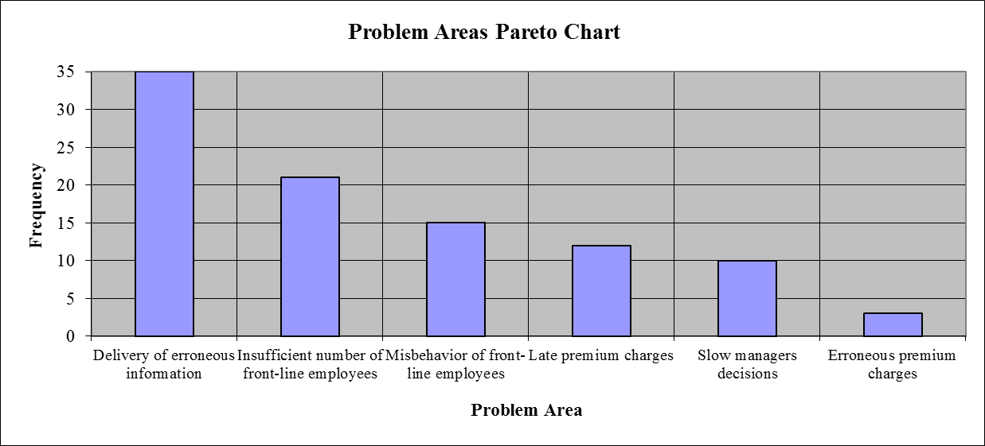
- As “Delivery of erroneous information” problem had the highest frequency amongst the other problems, Merlin decided to tackle this first. He decide to retrain his front-line employees on insurance contemporary related issues including government new regulations on the matter. After 16 weeks, he wanted to see if there are any quality improvements in the process. To see this, he decided to use run chart. He prepared the following table depicting monthly related guests’ complaints (before / after training). The following table reveals the results:
Week | Guest Complaints (Before) | Guest Complaints (After)
1 | 3 | 2
2 | 2 | 1
3 | 2 | 1
4 | 2 | 0
5 | 3 | 1
6 | 1 | 0
7 | 3 | 0
8 | 1 | 0
9 | 2 | 1
10 | 2 | 1
11 | 3 | 2
12 | 2 | 1
13 | 1 | 0
14 | 2 | 1
15 | 3 | 1
16 | 3 | 1
Prepare a run chart to compare guest complaints before and after re-training of front-line employees. (2 Points)

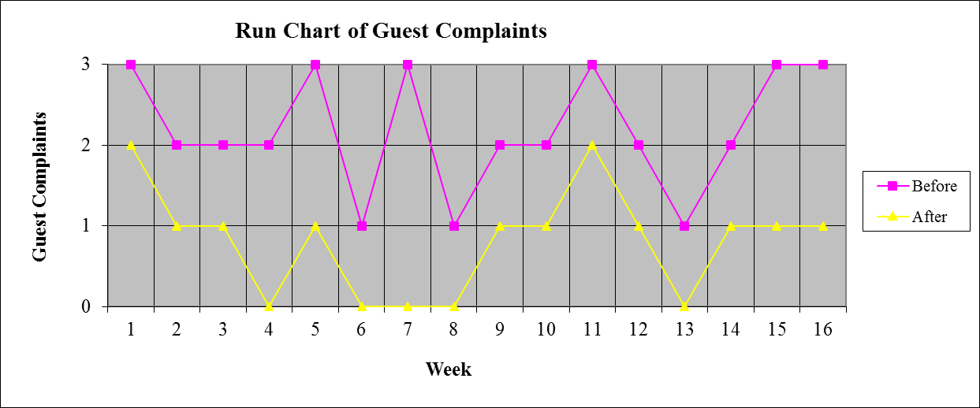

c) Analyze the finding in part b). Is there any improvement as far as guest complaints are concerned after retraining front-line employees? If there is an improvement, what is the next problem that Merlin shall try and solve? (1 Point)
As seen from the run chart prepared in part b), there is a clear improvement as far as guest complaints are concerned after retraining front-line employees. The next problem that Merlin shall try and solve is “Insufficient number of front-line employees”.
- Nowadays, social media plays an important role in the success of service firms. Could you come up with any 2 characteristics that social media shall provide for the success of any service firm? (2 Points)
Social media shall provide the following characteristics for the success of any service firm:
- A wide reach that is decentralized, less hierarchical, and has multiple points of production and consumption.
- Easy access that generally is available to the public at little or no cost.
- Ease of use that does not require specialized skills and training, or requires only modest reinterpretation of existing skills.
- Immediacy that allows instantaneous responses.
- Flexibility that allows information to be altered almost instantaneously by comments or editing.
- How does service consulting businesses use Processes and Plant (i.e. 2 of the traditional 5 Ps in operation) while developing their own strategies? (2 Points)
Service consulting businesses uses processes and plant while developing their own strategies in the following ways:
- Processes → process improvement, productivity improvement, and staffing decisions.
- Plant → service facility and layout planning.
- What are some of the advantages of branding? (3 Points)
Some of the advantages of branding are as follows:
- Reinforces operations programming
- Greater profit potential
- Reduced risk
- More sought-after investment opportunity.
- What is the main weakness faced by service companies “Following their Customers”? (2 Points)
The main weakness faced by service companies “following their customers” is that those very companies ignore the vast markets represented by the rapidly growing middle classes of many countries.
- During the past season, Mursey Resort Hotel did not achieve very high occupancy rates despite a reservation system that was designed to keep the hotel fully booked. Apparently, prospective guests were making reservations that, for one reason or another, they failed to honor. A review of Front-desk records during the current peak period, when the Resort Hotel was fully booked, revealed the record of no-shows as shown in the below table:

No-shows | Probability | Reservations Overbooked | Cumulative Probability
0 | 0.04 | 0 | 0.00
1 | 0.06 | 1 | 0.04
2 | 0.08 | 2 | 0.10
3 | 0.10 | 3 | 0.18
4 | 0.12 | 4 | 0.28
5 | 0.26 | 5 | 0.40
6 | 0.10 | 6 | 0.66
7 | 0.08 | 7 | 0.76
8 | 0.06 | 8 | 0.84
9 | 0.04 | 9 | 0.90
10 | 0.06 | 10 | 0.94

Suppose that a vacant room (because of No Show) results in an opportunity loss of $ 60.
- Calculate the Expected Number of No Show Rooms. (2 Points)
- Expected Number of No Show Rooms = (0 * 0.04) + (1 * 0.06) + (2 * 0.08) + (3 * 0.10) + (4 * 0.12) + (5 * 0.26) + (6 * 0.10) + (7 * 0.08) + (8 * 0.06) + (9 * 0.04) + (10 * 0.06) = 0 + 0.06 + 0.16 + 0.30 + 0.48 + 1.30 + 0.60 + 0.56 + 0.48 + 0.36 + 0.60 = 4.90 Rooms.
- Calculate the Expected Opportunity Loss. (1 Point)
- Expected Opportunity Loss = 4.90 * 60 = $ 294.00.
In order to avoid some of this loss, Mursey Resort Hotel management is considering an overbooking policy. Yet, if a guest holding a reservation is turned away (due to overbooking), other costs would be incurred. Mursey Resort Hotel has made arrangements with a nearby Resort Hotel (Sensin Resort Hotel) to pay for the rooms of guests whom it cannot accommodate. Further, a penalty is associated with the loss of customer goodwill and the impact this has on future business. Management estimates this total loss to be approximately $ 110 per turned out guest.
- Fill the below Overbooking Loss Table (3 Points)
 |  | Reservations Overbooked
No-shows | Prob. | 0 | 1 | 2 | 3 | 4 | 5 | 6 | 7 | 8 | 9 | 10
0 | 0.04 | 0.00 | 110.00 | 220.00 | 330.00 | 440.00 | 550.00 | 660.00 | 770.00 | 880.00 | 990.00 | 1,100.00
1 | 0.06 | 60.00 | 0.00 | 110.00 | 220.00 | 330.00 | 440.00 | 550.00 | 660.00 | 770.00 | 880.00 | 990.00
2 | 0.08 | 120.00 | 60.00 | 0.00 | 110.00 | 220.00 | 330.00 | 440.00 | 550.00 | 660.00 | 770.00 | 880.00
3 | 0.10 | 180.00 | 120.00 | 60.00 | 0.00 | 110.00 | 220.00 | 330.00 | 440.00 | 550.00 | 660.00 | 770.00
4 | 0.12 | 240.00 | 180.00 | 120.00 | 60.00 | 0.00 | 110.00 | 220.00 | 330.00 | 440.00 | 550.00 | 660.00
5 | 0.26 | 300.00 | 240.00 | 180.00 | 120.00 | 60.00 | 0.00 | 110.00 | 220.00 | 330.00 | 440.00 | 550.00
6 | 0.10 | 360.00 | 300.00 | 240.00 | 180.00 | 120.00 | 60.00 | 0.00 | 110.00 | 220.00 | 330.00 | 440.00
7 | 0.08 | 420.00 | 360.00 | 300.00 | 240.00 | 180.00 | 120.00 | 60.00 | 0.00 | 110.00 | 220.00 | 330.00
8 | 0.06 | 480.00 | 420.00 | 360.00 | 300.00 | 240.00 | 180.00 | 120.00 | 60.00 | 0.00 | 110.00 | 220.00
9 | 0.04 | 540.00 | 480.00 | 420.00 | 360.00 | 300.00 | 240.00 | 180.00 | 120.00 | 60.00 | 0.00 | 110.00
10 | 0.06 | 600.00 | 540.00 | 480.00 | 420.00 | 360.00 | 300.00 | 240.00 | 180.00 | 120.00 | 60.00 | 0.00
Expected | ------- | $294.00 | $240.80 | $197.80 | $168.40 | $156.00 | $164.00 | $216.20 | $285.40 | $368.20 | $461.20 | $561.00
Loss ($)

- How many rooms shall be overbooked? Why? (2 Points)
According to the above overbooking loss table, 4 rooms shall be overbooked, since, this very scenario yields the least expected loss.
N.B: Your answers to parts a), b) c) & d) shall be rounded to the nearest cent.
- Contrast “request variability” to “effort variability” as sources of customer-induced variability in service operations. Provide one example for each of the above variability forms. (3 Points)
While “request variability” results from the unique demands of customers that create uneven service times (example: a bank customer who wants to purchase government bonds and another customer who wants to pay a bill), “effort variability” denotes the level of commitment when customers are expected to perform a role in a service interaction (example: clear table at the end of meal at fast food restaurants).
Good Luck

